**Project Report**

**on**

**<PROJECT NAME>**



**Submitted By**

<Student Name1>

<Name2>

Class: XI D

**Under the Guidance of**

Ms. Angel Panesar

Department of Computer Science

Sardar Patel Vidyalaya

Lodhi Estate, New Delhi 110003

**CERTIFICATE**

This is to certify that <Student Name1>and <Name2>Of Class XI D have prepared the report on the Project entitled “<Project Name>”. The report is the result of their efforts & endeavors. The report is found worthy of acceptance as final project report for the subject Computer Science of Class XI. They have prepared the report under my guidance.

Ms. Angel Panesar

Department of Computer Science

Sardar Patel Vidyalaya

Lodhi Estate, New Delhi 110003

**DECLARATION**

We hereby declare that the project work entitled “<Project Name>”, submitted to Department of Computer Science, Sardar Patel Vidyalaya,Lodhi Estate, New Delhi 110003is prepared by us. The project workis result of our personal efforts.

<Student Name1>

<Name2>

Class: XI D

**ACKNOWLEDGEMENT**

/WRITE YOURSELF/

<Student Name1>

<Name2>

Class: XI D

**CONTENTS**

|  |  |  |
| --- | --- | --- |
| S. No. | Topic | Page No. |
| 1. |  |  |
| 2. |  |  |
| 3. |  |  |
| 4. |  |  |
| 5. |  |  |
| 6. |  |  |

**LIBRARIES USED**

* speech_recognition as sr
* webbrowser
* numpy as np
* cv2
* random
* playsound
* time
* wikipedia
* math
* sys

**WORKING DESCRIPTION**

[Note: Content will be of Font-Times New Roman and Size - 14; Line spacing – 1.15]

[This will include the list of modules in your project along with 1 paragraph description of each module]

[Should be 2-3 pages long]

**PROJECT CODE**

[Note: Content will be of Font-Courier New and Size - 14; Line spacing – 1.15]

**OUTPUT SCREENS**

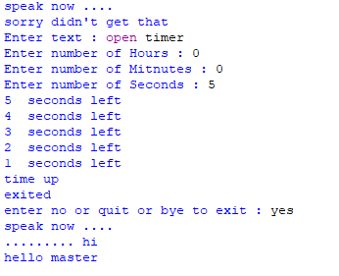

**CONCLUSION**

**BIBLIOGRAPHY**

1. Sumita Arora, *Computer Science with Python*, 2019

[Note: You can mention Wikipedia links, books, link to blogs. If you are mentioning any book, mention as– Author Name, Book Name, Edition. Add at least 5-7 references]